CPU Design Project

CMPEN 331 001

Summer 2021

Shao-Ju Wang

Introduction

Processors are very common today as the world is shifting to a data driven world. As the technology progress, processors become more powerful and efficient, making it more applicable to various situations. Therefore, designing a processor to fit in a certain application is important to engineers. This project requires us to design a MIPS processor as it is one of the simple RISV architecture, while satisfying many applications.

Abstract

I tried to add components and paths that will support a faster and diverse application by forwarding and adding multiplexers and adders to support other codes as in the previous labs. And add hazard control units in the control module to support new features. However, my estimation to the constructing time and the complexity of this CPU is wrong. Therefore, I wasn’t able to further test the set up after a problem in the IF stage.

*All Codes are at the bottom of this report as it’s too long.

**Waveform:**

For unknown reason, the pc kept swinging between the two values as shown above

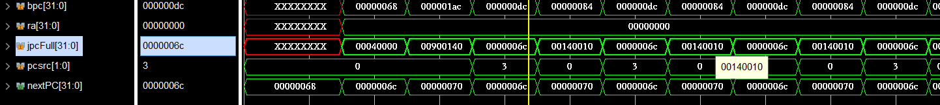

It may be due to the fact that pcsrc and the correct value of nextPC is off. However, I couldn’t find the error, so I can only leave it as it is.

**Design Schematic from synthesis (Datapath output is added, connected to WB output to form schematic):**

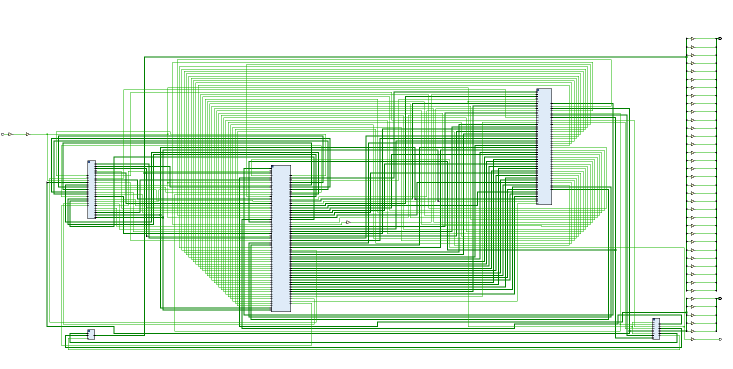

**Floor Planning:**

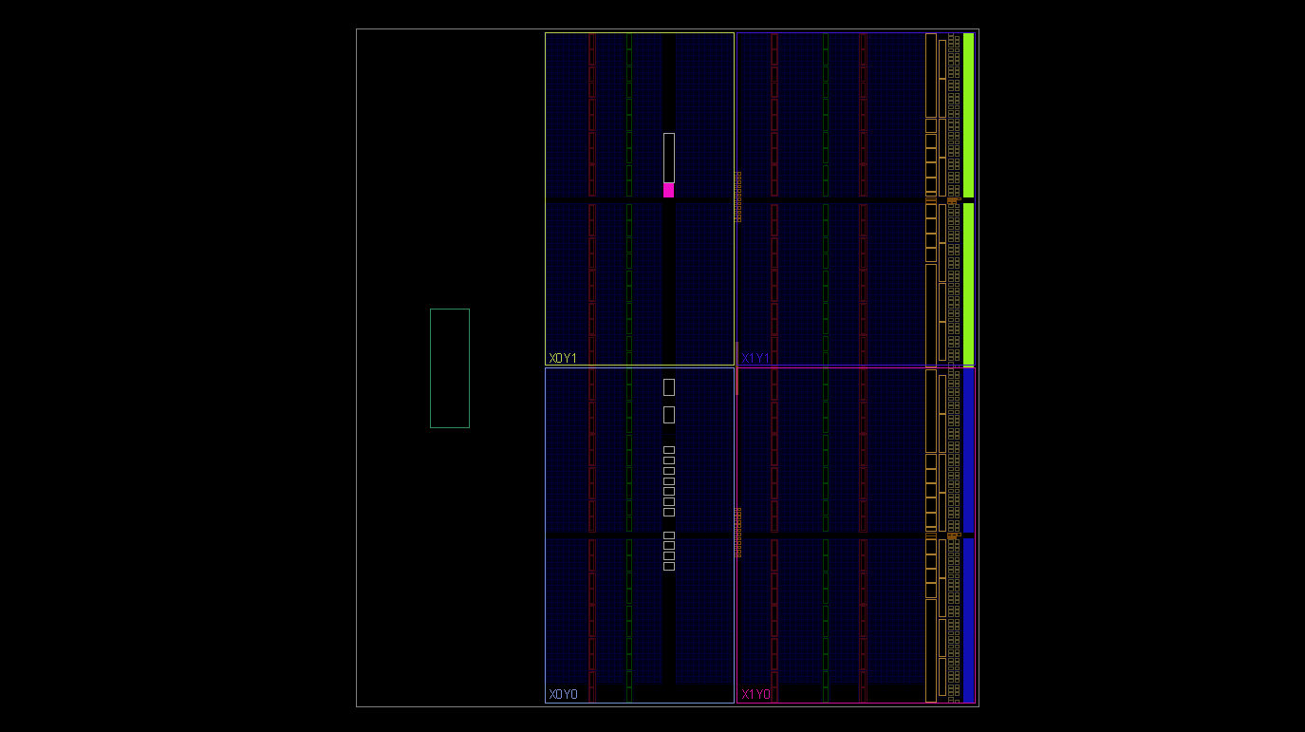

**I/O Planning:**

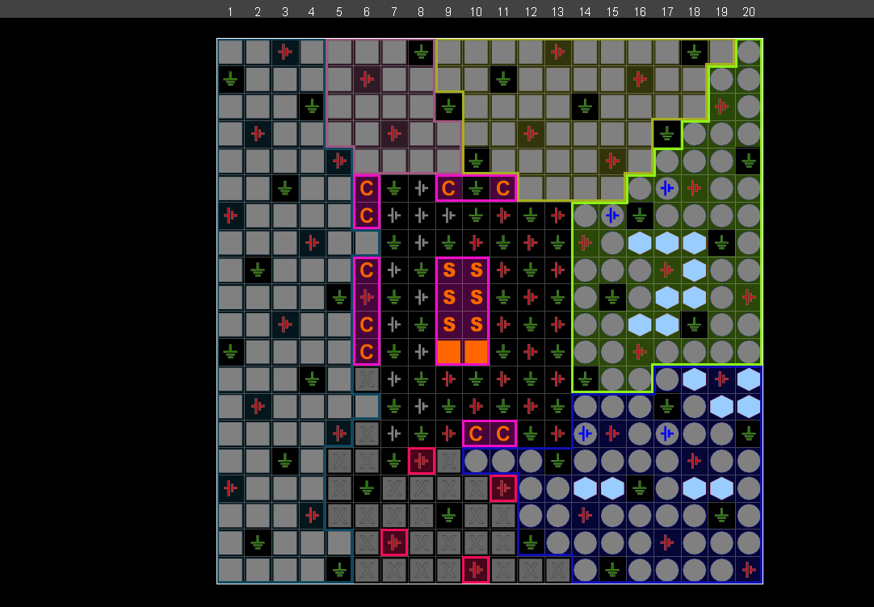

**Code** (Collapsible)**:**

**IF (InstFetch.v):**

`timescale 1ns/1ps

module pc(

input [31:0] nextPC,

input clk,

input wpcir,

output reg [31:0] pc

);

initial pc = 100;

always @(posedge clk) begin

if (wpcir) pc <= nextPC;

end

endmodule

module instMem(

input [31:0] pc,

output reg [31:0] instOut

);

reg [31:0] memory [0:63];

initial begin // Temp Assigned value

// memory[25] = {

// 6'b100011,

// 5'b00001,

// 5'b00010,

// 5'b00000,

// 5'b00000,

// 6'b000000

// };

// memory[26] = {

// 6'b100011,

// 5'b00001,

// 5'b00011,

// 5'b00000,

// 5'b00000,

// 6'b000100

// };

// memory[27] = {

// 6'b100011,

// 5'b00001,

// 5'b00100,

// 5'b00000,

// 5'b00000,

// 6'b001000

// };

// memory[28] = {

// 6'b100011,

// 5'b00001,

// 5'b00101,

// 5'b00000,

// 5'b00000,

// 6'b001100

// };

// memory[29] = {

// 6'b000000,

// 5'b00010, //2

// 5'b01010, //10

// 5'b00110, //6

// 5'b00000,

// 6'b100000

// };

memory[25] = 32'h3c010000; // (00) main: lui $1, 0

memory[26] = 32'h34240050; // (04) ori $4, $1, 80

memory[27] = 32'h0c00001b; // (08) call: jal sum

memory[28] = 32'h20050004; // (0c) dslot1: addi $5, $0, 4

memory[29] = 32'hac820000; // (10) return: sw $2, 0($4)

memory[30] = 32'h8c890000; // (14) lw $9, 0($4)

memory[31] = 32'h01244022; // (18) sub $8, $9, $4

memory[32] = 32'h20050003; // (1c) addi $5, $0, 3

memory[33] = 32'h20a5ffff; // (20) loop2: addi $5, $5, -1

memory[34] = 32'h34a8ffff; // (24) ori $8, $5, 0xffff

memory[35] = 32'h39085555; // (28) xori $8, $8, 0x5555

memory[36] = 32'h2009ffff; // (2c) addi $9, $0, -1

memory[37] = 32'h312affff; // (30) andi $10,$9,0xffff

memory[38] = 32'h01493025; // (34) or $6, $10, $9

memory[39] = 32'h01494026; // (38) xor $8, $10, $9

memory[40] = 32'h01463824; // (3c) and $7, $10, $6

memory[41] = 32'h10a00003; // (40) beq $5, $0, shift

memory[42] = 32'h00000000; // (44) dslot2: nop

memory[43] = 32'h08000008; // (48) j loop2

memory[44] = 32'h00000000; // (4c) dslot3: nop

memory[45] = 32'h2005ffff; // (50) shift: addi $5, $0, -1

memory[46] = 32'h000543c0; // (54) sll $8, $5, 15

memory[47] = 32'h00084400; // (58) sll $8, $8, 16

memory[48] = 32'h00084403; // (5c) sra $8, $8, 16

memory[49] = 32'h000843c2; // (60) srl $8, $8, 15

memory[50] = 32'h08000019; // (64) finish: j finish

memory[51] = 32'h00000000; // (68) dslot4: nop

memory[52] = 32'h00004020; // (6c) sum: add $8, $0, $0

memory[53] = 32'h8c890000; // (70) loop: lw $9, 0($4)

memory[54] = 32'h01094020; // (74) stall: add $8, $8, $9

memory[55] = 32'h20a5ffff; // (78) addi $5, $5, -1

memory[56] = 32'h14a0fffc; // (7c) bne $5, $0, loop

memory[57] = 32'h20840004; // (80) dslot5: addi $4, $4, 4

memory[58] = 32'h03e00008; // (84) jr $31

memory[59] = 32'h00081000; // (88) dslot6: sll $2, $8, 0

end

always @ (*) begin

instOut <= memory[pc[7:2]];

end

endmodule

module pcMUX(

input [31:0] pc4,

//For Proj Bonus

input [31:0] bpc,

input [31:0] ra,

input [31:0] jpcFull,

input [1:0] pcsrc,

output [31:0] nextPC

);

assign nextPC = (pcsrc == 2'd0)? pc4 : ((pcsrc == 2'd1)? bpc : ((pcsrc == 2'd2)? ra : jpcFull));

// always @ (*) begin

// case (pcsrc)

// 2'd0: nextPC <= pc4;

// 2'd1: nextPC <= bpc;

// 2'd2: nextPC <= ra;

// 2'd3: nextPC <= jpcFull;

// endcase

// end

endmodule

module pcAdd(

input [31:0] pc,

output [31:0] pc4

);

assign pc4 = pc + 32'd4;

endmodule

module IFIDreg(

input [31:0] instOut,

input clk,

//P

input wpcir,

//PB

input [31:0] pc4,

output reg [31:0] dinstOut,

//PB

output reg [31:0] dpc4

);

always @ (posedge clk) begin

if (wpcir) begin

dinstOut <= instOut;

dpc4 <= pc4;

end

end

endmodule

module InstFetch(

input clk,

//For Proj

input wpcir,

//For Proj Bonus

input [31:0] bpc,

input [31:0] ra,

input [31:0] jpcFull,

input [1:0] pcsrc,

output [31:0] dinstOut,

//PB

output [31:0] dpc4

);

wire [31:0] wpc;

wire [31:0] wnextPC;

wire [31:0] winstOut;

wire [31:0] pc4;

wire [31:0] wpc4;

pc pc1(wnextPC, clk, wpcir, wpc);

pcAdd pa(wpc, wpc4);

pcMUX pcm(wpc4, bpc, ra, jpcFull, pcsrc, wnextPC);

instMem inmem(wpc, winstOut);

IFIDreg IFID(winstOut, clk, wpcir, wpc4, dinstOut, dpc4);

endmodule

**ID (InstDecode.v):**

module Control(

input [5:0] op,

input [5:0] func,

//For Proj

input [4:0] rs, rt, mdestReg,

input mm2Reg, mwreg,

input [4:0] edestReg,

input em2Reg, ewreg,

//For Proj Bonus

input RsrtEqu,

output reg wreg,

output reg m2reg,

output reg wmem,

output reg [3:0] aluc,

output reg aluImm,

output reg regrt,

//For Proj

output reg [1:0] fwd_A, fwd_B,

output reg wpcir,

//For Proj Bonus

output reg jal,

output reg shift,

output reg sext,

output reg [1:0] pcsrc

);

//For Proj

reg regUsage;

initial begin

wreg <= 0;

pcsrc <= 0;

//regUsage <= 1; //Just For Testing

end

always @(*) begin

//Stalling

if (ewreg && em2Reg && (edestReg != 0) && regUsage && (edestReg == rs || edestReg == rt))

begin

wreg <= 0;

wmem <= 0;

wpcir <= 0;

end

else wpcir <= 1;

//Forwarding

if (ewreg & (edestReg != 0) & (edestReg == rs) & ~em2Reg) fwd_A <= 1;

else if (mwreg & (mdestReg != 0) & (mdestReg == rs) & ~mm2Reg) fwd_A <= 2;

else if (mwreg & (mdestReg != 0) & (mdestReg == rs) & mm2Reg) fwd_A <= 3;

else fwd_A <= 0;

if (ewreg & (edestReg != 0) & (edestReg == rt) & ~em2Reg) fwd_B <= 1;

else if (mwreg & (mdestReg != 0) & (mdestReg == rt) & ~mm2Reg) fwd_B <= 2;

else if (mwreg & (mdestReg != 0) & (mdestReg == rt) & mm2Reg) fwd_B <= 3;

else fwd_B <= 0;

//Normal Control

case (op)

6'b000000: //r-type

begin

case (func)

6'b100000: //Add

begin

wreg <= 1;

m2reg <= 0;

wmem <= 0;

aluc <= 4'b0010;

aluImm <= 0;

regrt <= 0;

jal <= 0;

shift <= 0;

sext <= 1;

pcsrc <= 2'd0;

regUsage <= 1;

end

6'b100010: //sub

begin

wreg <= 1;

m2reg <= 0;

wmem <= 0;

aluc <= 4'b0110;

aluImm <= 0;

regrt <= 0;

jal <= 0;

shift <= 0;

sext <= 1;

pcsrc <= 2'd0;

regUsage <= 1;

end

6'b100100: //and

begin

wreg <= 1;

m2reg <= 0;

wmem <= 0;

aluc <= 4'b0000;

aluImm <= 0;

regrt <= 0;

jal <= 0;

shift <= 0;

sext <= 1;

pcsrc <= 2'd0;

regUsage <= 1;

end

6'b100101: //or

begin

wreg <= 1;

m2reg <= 0;

wmem <= 0;

aluc <= 4'b0001;

aluImm <= 0;

regrt <= 0;

jal <= 0;

shift <= 0;

sext <= 1;

pcsrc <= 2'd0;

regUsage <= 1;

end

6'b100110: //xor

begin

wreg <= 1;

m2reg <= 0;

wmem <= 0;

aluc <= 4'b0111;

aluImm <= 0;

regrt <= 0;

jal <= 0;

shift <= 0;

sext <= 1;

pcsrc <= 2'd0;

regUsage <= 1;

end

6'b000000: //sll

begin

wreg <= 1;

m2reg <= 0;

wmem <= 0;

aluc <= 4'b1010;

aluImm <= 0;

regrt <= 0;

jal <= 0;

shift <= 1;

sext <= 1;

pcsrc <= 2'd0;

regUsage <= 1;

end

6'b000010: //srl

begin

wreg <= 1;

m2reg <= 0;

wmem <= 0;

aluc <= 4'b1100;

aluImm <= 0;

regrt <= 0;

jal <= 0;

shift <= 1;

sext <= 1;

pcsrc <= 2'd0;

regUsage <= 1;

end

6'b000010: //sra

begin

wreg <= 1;

m2reg <= 0;

wmem <= 0;

aluc <= 4'b1011;

aluImm <= 0;

regrt <= 0;

jal <= 0;

shift <= 1;

sext <= 1;

pcsrc <= 2'd0;

regUsage <= 1;

end

endcase

end

6'b100011: //lw

begin

wreg <= 1;

m2reg <= 1;

wmem <= 0;

aluc <= 4'b0010;

aluImm <= 1;

regrt <= 1;

jal <= 0;

shift <= 0;

sext <= 1;

pcsrc <= 2'd0;

regUsage <= 1;

end

6'b101011: //sw

begin

wreg <= 0;

m2reg <= 0;

wmem <= 1;

aluc <= 4'b0010;

aluImm <= 1;

regrt <= 1;

jal <= 0;

shift <= 0;

sext <= 1;

pcsrc <= 2'd0;

regUsage <= 1;

end

6'b001000: //addi //not sure

begin

wreg <= 1;

m2reg <= 0;

wmem <= 0;

aluc <= 4'b0010;

aluImm <= 1;

regrt <= 1;

jal <= 0;

shift <= 0;

sext <= 0;

pcsrc <= 2'd0;

regUsage <= 1;

end

6'b001100: //andi //not sure

begin

wreg <= 1;

m2reg <= 0;

wmem <= 0;

aluc <= 4'b0000;

aluImm <= 1;

regrt <= 1;

jal <= 0;

shift <= 0;

sext <= 0;

pcsrc <= 2'd0;

regUsage <= 1;

end

6'b001101: //ori //not sure

begin

wreg <= 1;

m2reg <= 0;

wmem <= 0;

aluc <= 4'b0001;

aluImm <= 1;

regrt <= 1;

jal <= 0;

shift <= 0;

sext <= 0;

pcsrc <= 2'd0;

regUsage <= 1;

end

6'b001110: //xori

begin

wreg <= 1;

m2reg <= 0;

wmem <= 0;

aluc <= 4'b0111;

aluImm <= 1;

regrt <= 1;

jal <= 0;

shift <= 0;

sext <= 0;

pcsrc <= 2'd0;

regUsage <= 1;

end

6'b000100: //beq

begin

if (RsrtEqu) pcsrc <= 2'd1;

else pcsrc <= 2'd0;

jal <= 0;

shift <= 0;

sext <= 1;

regUsage <= 1;

end

6'b000101: //bne

begin

if (RsrtEqu) pcsrc <= 2'd0;

else pcsrc <= 2'd1;

jal <= 0;

shift <= 0;

sext <= 1;

regUsage <= 1;

end

6'b001111: //lui

begin

wreg <= 1;

m2reg <= 0;

wmem <= 0;

aluc <= 4'b1110;

aluImm <= 1;

regrt <= 1;

jal <= 0;

shift <= 0;

sext <= 0;

pcsrc <= 2'd0;

regUsage <= 0;

end

6'b000010: //j

begin

pcsrc <= 2'd3;

jal <= 0;

shift <= 0;

sext <= 1;

wreg <= 0;

wmem <= 0;

regUsage <= 0;

end

6'b000011: //jal

begin

jal <= 1;

pcsrc <= 2'd3;

shift <= 0;

sext <= 1;

wreg <= 1;

wmem <= 0;

regUsage <= 0;

m2reg <= 0;

end

6'b000011: //jr

begin

pcsrc <= 2'd2;

jal <= 0;

shift <= 0;

sext <= 1;

wreg <= 0;

wmem <= 0;

regUsage <= 0;

end

endcase

end

endmodule

module forwardMux(

input [1:0] fwd,

input [31:0] regOut, r, mr, mdo,

output reg [31:0] q

);

always @ (*) begin

case (fwd)

2'd0: q <= regOut;

2'd1: q <= r;

2'd2: q <= mr;

2'd3: q <= mdo;

endcase

end

endmodule

module jump(

input [25:0] addr,

input [31:0] dcp4,

output [31:0] jpcFull

);

wire [31:0] jpc;

wire [29:0] temp;

assign temp = {4'd0, addr};

assign jpc = temp << 2;

assign jpcFull = {dcp4[31:28], jpc[27:0]};

endmodule

module Branch(

input [15:0] imm,

input [31:0] dpc4,

//output [31:0] imm18

output [31:0] bpc

);

assign bpc = {{{16'd0}, imm} << 2} + dpc4;

endmodule

module equCheck(

input [31:0] qa, qb,

output rsrtequ

);

assign rsrtequ = (qa == qb) ? 1'b1 : 1'b0;

endmodule

module regRTMux(

input [4:0] rt,

input [4:0] rd,

input regrt,

output reg [4:0] destReg

);

always @ (*) begin

if (~regrt) destReg <= rd;

else if (regrt) destReg <= rt;

end

endmodule

module regFile(

input [4:0] rs,

input [4:0] rt,

input wwreg,

input [4:0] wdestReg,

input [31:0] wbData,

input clk,

output reg [31:0] qa,

output reg [31:0] qb

);

reg [31:0] registers [0:31];

initial //Initialize RegFile

begin

registers[0] = 32'd0;

registers[1] = 32'd0;

registers[2] = 32'd0;

registers[3] = 32'd0;

registers[4] = 32'd0;

registers[5] = 32'd0;

registers[6] = 32'd0;

registers[7] = 32'd0;

registers[8] = 32'd0;

registers[9] = 32'd0;

registers[10] = 32'd0;

registers[11] = 32'd0;

registers[12] = 32'd0;

registers[13] = 32'd0;

registers[14] = 32'd0;

registers[15] = 32'd0;

registers[16] = 32'd0;

registers[17] = 32'd0;

registers[18] = 32'd0;

registers[19] = 32'd0;

registers[20] = 32'd0;

registers[21] = 32'd0;

registers[22] = 32'd0;

registers[23] = 32'd0;

registers[24] = 32'd0;

registers[25] = 32'd0;

registers[26] = 32'd0;

registers[27] = 32'd0;

registers[28] = 32'd0;

registers[29] = 32'd0;

registers[30] = 32'd0;

registers[31] = 32'd0;

end

always @ (*) begin

qa = registers[rs];

qb = registers[rt];

end

always @ (negedge clk) begin

if (wwreg) begin

registers[wdestReg] <= wbData;

end

end

endmodule

module ImmExt(

input [15:0] imm,

input sext,

output reg [31:0] imm32

);

always @ (*) begin

if (sext) imm32 <= {{17{imm[15]}}, imm[14:0]};

else imm32 <= {{17'd0}, imm[14:0]};

end

endmodule

module IDEXEreg(

input wreg,

input m2reg,

input wmem,

input [3:0] aluc,

input aluimm,

input [4:0] destReg,

input [31:0] qa,

input [31:0] qb,

input [31:0] imm32,

input clk,

//For Bonus

input jal, shift,

input [31:0] dpc4,

output reg owreg,

output reg om2reg,

output reg owmem,

output reg [3:0] oaluc,

output reg oaluimm,

output reg [4:0] odestReg,

output reg [31:0] oqa,

output reg [31:0] oqb,

output reg [31:0] oimm32,

//For Bonus

output reg ejal, eshift,

output reg [31:0] epc4

);

always @ (posedge clk) begin

owreg <= wreg;

om2reg <= m2reg;

owmem <= wmem;

oaluc <= aluc;

oaluimm <= aluimm;

odestReg <= destReg;

oqa <= qa;

oqb <= qb;

oimm32 <= imm32;

ejal <= jal;

eshift <= shift;

epc4 <= dpc4;

end

endmodule

module InstDecode(

input [31:0] dinstOut,

input wwreg,

input [4:0] wdestReg,

input [31:0] wbData,

input clk,

//For Proj

input [4:0] mdestReg,

input mm2Reg, mwreg,

input [4:0] edestReg,

input em2Reg, ewreg,

//PB

input [31:0] dpc4, r, mr, mdo,

output owreg,

output om2reg,

output owmem,

output [3:0] oaluc,

output oaluimm,

output [4:0] odestReg,

output [31:0] oqa,

output [31:0] oqb,

output [31:0] oimm32,

//For Proj

output wpcir,

//For Proj Bonus

output [1:0] pcsrc,

output [31:0] jpcFull, bpc,

output [31:0] ra,

output ejal, eshift,

output [31:0] epc4

);

wire wreg;

wire wm2reg;

wire wwmem;

wire [3:0] waluc;

wire waluimm;

wire [4:0] destReg;

wire [31:0] wqa;

wire [31:0] wqb;

wire [31:0] wimm32;

wire wrtMUX;

//For Proj

wire [1:0] fwd_A, fwd_B;

wire [31:0] Fqa, Fqb;

//For Proj Bonus

wire jal, shift, sext;

wire RsrtEqu;

assign ra = Fqa;

Control c(dinstOut[31:26], dinstOut[5:0], dinstOut[25:21], dinstOut[20:16], mdestReg, mm2Reg, mwreg, edestReg, em2Reg, ewreg, RsrtEqu, //input

wreg, wm2reg, wwmem, waluc, waluimm, wrtMUX, fwd_A, fwd_B, wpcir, jal, shift, sext, pcsrc); //Output

forwardMux fwdA(fwd_A, wqa, r, mr, mdo, Fqa);

forwardMux fwdB(fwd_B, wqb, r, mr, mdo, Fqb);

jump j(dinstOut[25:0], dpc4, jpcFull);

Branch b(dinstOut[16:0], dpc4, bpc);

equCheck equ(Fqa, Fqb, RsrtEqu);

regRTMux rtMux(dinstOut[20:16], dinstOut[15:11], wrtMUX, destReg);

regFile rf(dinstOut[25:21], dinstOut[20:16], wwreg, wdestReg, wbData, clk, wqa, wqb);

ImmExt extend(dinstOut[15:0], sext, wimm32);

IDEXEreg idexe1(wreg, wm2reg, wwmem, waluc, waluimm, destReg, Fqa, Fqb, wimm32, clk, jal, shift, dpc4,

owreg, om2reg, owmem, oaluc, oaluimm, odestReg, oqa, oqb, oimm32, ejal, eshift, epc4);

endmodule

**Execution (Exe.v):**

module aluMUX (

input [31:0] eqb,

input [31:0] eimm,

input ealuimm,

output reg [31:0] b

);

always @ (*)

begin

if (ealuimm) b <= eimm;

else b <= eqb;

end

endmodule

module Alu(

input [31:0] eqa,

input [31:0] b,

input [3:0] ealuc,

output reg [31:0] r

);

always @(*)

begin

case (ealuc)

4'b0000: r <= eqa & b;

4'b0001: r <= eqa | b;

4'b0010: r <= eqa + b;

4'b0110: r <= eqa - b;

4'b0111: r <= eqa ^ b; //xor

4'b1010: r <= b << eqa[10:6]; //sll

4'b1100: r <= b >> eqa[10:6]; //srl

4'b1011: r <= b >>> eqa[10:6]; //sra

4'b1110: r <= {b[31:16], 15'd0};

endcase

end

endmodule

module shiftMux(

input [31:0] sa, eqa,

input shift,

output [31:0] a

);

assign a = (shift) ? sa : eqa;

endmodule

module jal(

input [31:0] epc4, ealu,

input ejal,

output [31:0] er

);

assign er = (ejal) ? (epc4 + 32'd4) : ealu;

endmodule

module f(

input jal,

input [4:0] destReg,

output [4:0] edestReg

);

assign edestReg = (jal) ? 5'd31 : destReg;

endmodule

module exemem(

input ewreg,

input em2reg,

input ewmem,

input [4:0] edestReg,

input [31:0] r,

input [31:0] eqb,

input clk,

output reg mwreg,

output reg mm2reg,

output reg mwmem,

output reg [4:0] mdestReg,

output reg [31:0] mr,

output reg [31:0] mqb

);

always @ (posedge clk) begin

mwreg <= ewreg;

mm2reg <= em2reg;

mwmem <= ewmem;

mdestReg <= edestReg;

mr <= r;

mqb <= eqb;

end

endmodule

module Exe(

input ewreg,

input em2reg,

input ewmem,

input [3:0] ealuc,

input ealuimm,

input [4:0] edestReg,

input [31:0] eqa,

input [31:0] eqb,

input [31:0] eimm32,

input clk,

//Bonus

input ejal, eshift,

input [31:0] epc4,

output mwreg,

output mm2reg,

output mwmem,

output [4:0] mdestReg,

output [31:0] mr,

output [31:0] mqb,

//Proj

output [31:0] er,

//For Bonus //To control

output [4:0] CEdestReg,

output CEwreg, CEm2reg

);

wire [31:0] rWire;

wire [31:0] bWire;

wire [31:0] aluOut, a;

wire [4:0] fdestReg;

assign CEdestReg = fdestReg;

assign CEwreg = ewreg;

assign CEm2reg = em2reg;

assign er = rWire;

aluMUX almu(eqb, eimm32, ealuimm, bWire);

shiftMux sft(eimm32, eqa, eshift, a);

Alu alu(a, bWire, ealuc, aluOut);

jal jl(epc4, aluOut, ejal, rWire);

f ff(ejal, edestReg, fdestReg);

exemem em(ewreg, em2reg, ewmem, fdestReg, rWire, eqb, clk, mwreg, mm2reg, mwmem, mdestReg, mr, mqb);

endmodule

**Memory (Mem.v):**

`timescale 1ns / 1ps

//////////////////////////////////////////////////////////////////////////////////

// Company:

// Engineer:

//

// Create Date: 2021/07/15 21:32:52

// Design Name:

// Module Name: Mem

// Project Name:

// Target Devices:

// Tool Versions:

// Description:

//

// Dependencies:

//

// Revision:

// Revision 0.01 - File Created

// Additional Comments:

//

//////////////////////////////////////////////////////////////////////////////////

module Main_Mem(

input [31:0] mr,

input [31:0] mqb,

input mwmem,

input clk,

output reg [31:0] mdo

);

reg [31:0] mem [0:63];

integer i;

initial begin

// mem[0] = 32'hA00000AA;

// mem[1] = 32'h10000011;

// mem[2] = 32'h20000022;

// mem[3] = 32'h30000033;

// mem[4] = 32'h40000044;

// mem[5] = 32'h50000055;

// mem[6] = 32'h60000066;

// mem[7] = 32'h70000077;

// mem[8] = 32'h80000088;

// mem[9] = 32'h90000099;

for (i = 0; i < 32; i = i + 1)

mem[i] = 0;

// ram[word_addr] = data // (byte_addr) item in data array

mem[5'h14] = 32'h000000a3; // (50) data[0] 0 + a3 = a3

mem[5'h15] = 32'h00000027; // (54) data[1] a3 + 27 = ca

mem[5'h16] = 32'h00000079; // (58) data[2] ca + 79 = 143

mem[5'h17] = 32'h00000115; // (5c) data[3] 143 + 115 = 258

// ram[5'h18] should be 0x00000258, the sum stored by sw instruction

end

always @ (*) begin

mdo <= mem[mr[7:2]];

end

always @ (negedge clk) begin

if (mwmem) begin

mem[mr[7:2]] <= mqb;

end

end

endmodule

module memwb(

input mwreg,

input mm2reg,

input [4:0] mdestReg,

input [31:0] mr,

input [31:0] mdo,

input clk,

output reg wwreg,

output reg wm2reg,

output reg [4:0] wdestReg,

output reg [31:0] wr,

output reg [31:0] wdo

);

always @ (posedge clk) begin

wwreg <= mwreg;

wm2reg <= mm2reg;

wdestReg <= mdestReg;

wr <= mr;

wdo <= mdo;

end

endmodule

module Mem(

input mwreg,

input mm2reg,

input mwmem,

input [4:0] mdestReg,

input [31:0] mr,

input [31:0] mqb,

input clk,

output wwreg,

output wm2reg,

output [4:0] wdestReg,

output [31:0] wr,

output [31:0] wdo,

//For Proj

output [31:0] Cmr, Cmdo,

//For Bonus //To control

output [4:0] CMdestReg,

output CMwreg, CMm2reg

);

wire [31:0] doWire;

assign Cmr = mr;

assign Cmdo = doWire;

assign CMdestReg = mdestReg;

assign CMwreg = mwreg;

assign CMm2reg = mm2reg;

Main_Mem m(mr, mqb, mwmem, clk, doWire);

memwb mw(mwreg, mm2reg, mdestReg, mr, doWire, clk, wwreg, wm2reg, wdestReg, wr, wdo);

endmodule

**Write Back (WB.v):**

`timescale 1ns / 1ps

//////////////////////////////////////////////////////////////////////////////////

// Company:

// Engineer:

//

// Create Date: 2021/07/31 12:42:51

// Design Name:

// Module Name: WB

// Project Name:

// Target Devices:

// Tool Versions:

// Description:

//

// Dependencies:

//

// Revision:

// Revision 0.01 - File Created

// Additional Comments:

//

//////////////////////////////////////////////////////////////////////////////////

module WbMUX(

input wm2reg,

input [31:0] wr,

input [31:0] wdo,

output [31:0] wbData

);

assign wbData = wm2reg ? wdo : wr;

endmodule

module WB(

input wwreg,

input wm2reg,

input [4:0] wdestReg,

input [31:0] wr,

input [31:0] wdo,

output wreg,

output [4:0] destReg,

output [31:0] wbData

);

assign wreg = wwreg;

assign destReg = wdestReg;

WbMUX wbm(wm2reg, wr, wdo, wbData);

endmodule

**Datapath (DataPath.v):**

`timescale 1ns / 1ps

//////////////////////////////////////////////////////////////////////////////////

// Company:

// Engineer:

//

// Create Date: 2021/07/04 10:25:31

// Design Name:

// Module Name: DataPath

// Project Name:

// Target Devices:

// Tool Versions:

// Description:

//

// Dependencies:

//

// Revision:

// Revision 0.01 - File Created

// Additional Comments:

//

//////////////////////////////////////////////////////////////////////////////////

module DataPath(

input clk,

//temp

// output WB_wreg,

// output [4:0] WB_destReg,

// output [31:0] WB_wbData

// output wwreg,

// output wm2reg,

// output [4:0] wdestReg,

// output [31:0] wr,

// output [31:0] wdo

//Just for schematics

output Out_wreg,

output [4:0] Out_destReg,

output [31:0] Out_wbData

);

//IF to ID

wire [31:0] inst;

// ID to Exe

wire [31:0] qa;

wire [31:0] qb;

wire [31:0] imm32;

wire wreg;

wire m2reg;

wire wmem;

wire aluimm;

wire [3:0] aluc;

wire [4:0] destReg;

//Exe to Mem

wire mwreg;

wire mm2reg;

wire mwmem;

wire [4:0] mdestReg;

wire [31:0] mr, mqb;

//Mem to WB

wire wwreg;

wire wm2reg1;

wire [4:0] wdestReg;

wire [31:0] wr;

wire [31:0] wdo;

//WB

wire WB_wreg;

wire [4:0] WB_destReg;

wire [31:0] WB_wbData;

//For Proj

//IF to ID

wire [1:0] pcsrc;

wire [31:0] ra, jpcFull, bpc, dpc;

wire wpcir;

//ID to Other

wire [4:0] CmdestReg;

wire Cmm2Reg, Cmwreg;

wire [4:0] CedestReg;

wire Cem2Reg, Cewreg;

wire [31:0] dpc4, Dr, Dmr, Dmdo;

wire ejal, eshift;

wire [31:0] epc4;

InstFetch if1(clk, wpcir, bpc, ra, jpcFull, pcsrc, inst, dpc);

InstDecode id(inst, WB_wreg, WB_destReg, WB_wbData, clk, CmdestReg, Cmm2Reg, Cmwreg, CedestReg, Cem2Reg, Cewreg, dpc, Dr, Dmr, Dmdo,

wreg, m2reg, wmem, aluc, aluimm, destReg, qa, qb, imm32, wpcir, pcsrc, jpcFull, bpc, ra, ejal, eshift, epc4);

Exe ex(wreg, m2reg, wmem, aluc, aluimm, destReg, qa, qb, imm32, clk, ejal, eshift, epc4,

mwreg, mm2reg, mwmem, mdestReg, mr, mqb, Dr, CedestReg, Cewreg, Cem2Reg);

Mem me(mwreg, mm2reg, mwmem, mdestReg, mr, mqb, clk, wwreg, wm2reg1, wdestReg, wr, wdo, Dmr, Dmdo, CmdestReg, Cmwreg, Cmm2Reg);

WB w(wwreg, wm2reg1, wdestReg, wr, wdo, WB_wreg, WB_destReg, WB_wbData);

//Just for schematics

assign Out_wreg = WB_wreg;

assign Out_destReg = WB_destReg;

assign Out_wbData = WB_wbData;

endmodule

**Test Bench (TB.v):**

`timescale 1ns / 1ps

//////////////////////////////////////////////////////////////////////////////////

// Company:

// Engineer:

//

// Create Date: 2021/07/04 16:12:05

// Design Name:

// Module Name: TestBench

// Project Name:

// Target Devices:

// Tool Versions:

// Description:

//

// Dependencies:

//

// Revision:

// Revision 0.01 - File Created

// Additional Comments:

//

//////////////////////////////////////////////////////////////////////////////////

module TestBench();

reg clk;

// wire TB_wreg;

// wire TB_m2reg;

// wire [4:0] TB_wdestReg;

// wire [31:0] TB_wr;

// wire [31:0] TB_wdo;

DataPath dp (clk);

//, TB_wreg, TB_m2reg, TB_wdestReg, TB_wr, TB_wdo

initial begin

clk = 0;

#100 $finish;

end

always begin

#5;

clk = ~clk;

end

endmodule

Note: In the Original code, the Datapath doesn’t have output, so TB is based on the output-less code. The Datapath with output above is just for generating schematics, other pictures/code are based on the original code.